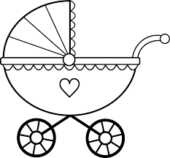
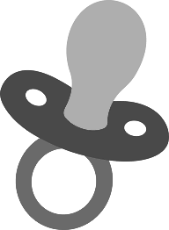
Human Variations Activity

Background A large variety of traits exist in the human population. The large number of combinations of these traits causes individuals to look unique, or different, from everyone else. This lab exercise will help you understand the many possible combinations available to offspring as they are being produced. You and a partner will become “parents” and produce a “baby” or "offspring". What your baby will look like will depend on the laws of probability and genetics.

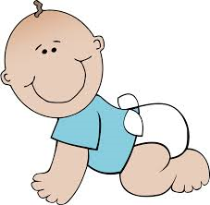
Objectives Students will determine the appearance of their child's face; by drawing Punnett Squares and flipping coins to determine the pairing of the alleles for each of the major characteristics. Students will practice writing gene combinations and differentiating between dominant, recessive, heterozygous, and homozygous.

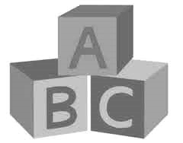
Materials 2 coins, "Variations of a Human Face- Your Genetic Fingerprint" Handout

Procedure

Pair up with a partner for this experiment.

If your pair is the same sex, determine which of the group will be the "father" and the "mother".

#1 Determine the Sex of your offspring:  Females (XX) can only donate an X sex chromosome; males (XY) can donate an X or a Y. Therefore the father will flip the coin to determine the sex of child.  If the father flips head, this indicates the child will be a Girl (he gives allele X)  If the father flips tails, this indicates the child will be a Boy (he gives allele Y). | Punnett Square for Sex Chromosomes:  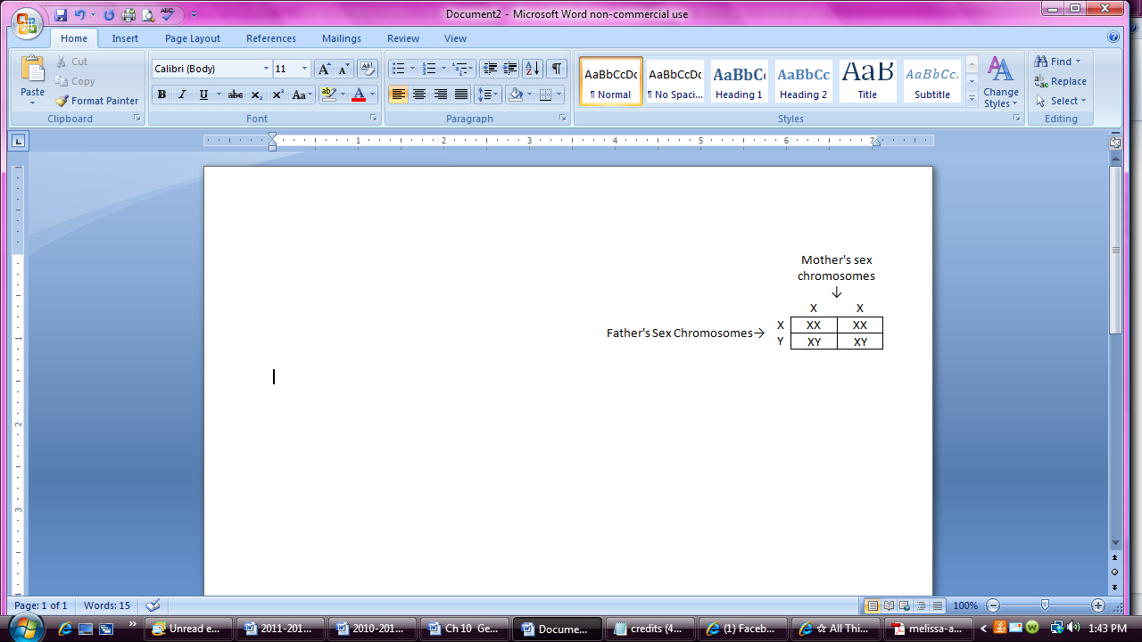  A baby’s sex is determined by the male’s sperm and which sex chromosome it contains; either X or Y.

#2-32 Each person in the group will donate one allele to each child for each trait:

Look at your “Variations of a Human Face” handout, then write your genotype for each trait in the boxes labeled Mother or Father’s Genes. Use these letters to complete your Punnett Square.

If you were dominant and circled two genotypes, we will not know for sure if you are homozygous dominant or heterozygous (For animals we could do a test cross. For humans, this is not ethical). So for each dominant trait, flip a coin to determine which genotype to write down for your gene. Heads side you will write down homozygous dominant and the tails side you will write down heterozygous.

Complete the Punnett square to combine the alleles for the mother and father’s genes and look up the phenotype on your “Variations of a Human Face” handout.

If there is more than one possible phenotype for a child (meaning one or both of the parents were heterozygous, the heterozygous parent(s) need to flip a coin to determine which gene they are passing on (dominant or recessive)

A heterozygous parent has a 50/50 chance of passing on either trait to their child. The heterozygous parents should flip a coin to determine which trait they will pass on (designate the heads side as dominant and the tails side as recessive).

If you have homozygous dominant alleles for a trait, you can only pass on the dominant allele, therefore no need to flip the coin.

If you have homozygous recessive alleles for a trait, you can only pass on the recessive allele, therefore no need to flip the coin.

After flipping coins, circle your child’s genotype in the Punnett Square where the mother and father’s donated alleles overlap. Use your Genetic Fingerprint handout to look up your child’s phenotype and record it in the appropriate box. Do not abbreviate, write it out (ex. “round face”).

Trait | Mother's Genes | Father's Genes | Punnett Square (male should flip coin; heads = X; tails =Y; then circle child’s genotype) | Child's Phenotype
1. Sex of child | XX | XY |  | Circle: Male or Female
Trait | Mother's Genes | Father's Genes | Punnett Square (if needed flip coin(s) then circle genotype)  R R  R RR RR  r Rr Rr | Write out the Child's Phenotype  (appearance) Do not abbreviate
2. face shape | -RR | Rr | 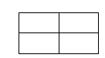 | ----Round Face
3. chin shape | ------------  Answers will vary.  Make sure students have:  - Filled in mother’s and father’s genes and wrote the genotypes in correct form  - Correctly completed Punnett Squares  - Circled the genotype in the Punnett Square (which they figured out by flipping coins for heterozygous traits)  - Listed the child’s phenotype | ------------ |  | ------------
4. jawline shape
5. cleft chin | ------------ | ------------ |  | ------------
6. hair shape | ------------ | ------------ |  | ------------
7. widow's peak | ------------ | ------------ |  | ------------
8. hair color  Students may need to flip coins twice for heterozygous dihybrid traits. Ex. AaBb – Flip for A & B | ------------ | ------------ | 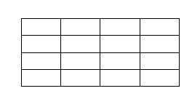 |  | ------------
9. eyebrow thickness
Trait | Mother's Genes | Father's Genes | Punnett Square (if needed flip coin(s) then circle genotype)  N n  N NN Nn  n Nn nn | Write out the Child's Phenotype  (appearance)
10. eyebrow connectedness | -Nn | Nn |  | ---Connected
11. eyebrow color | Answers will vary.  Make sure students have:  - Filled in mother’s and father’s genes and wrote the genotypes in correct form  - Correctly completed Punnett Squares  - Circled the genotype in the Punnett Square (which they figured out by flipping coins for heterozygous traits)  - Listed the child’s phenotype
12. eye distance | ------------ | ------------ |  | ------------
13. eye size | ------------ | ------------ |  | ------------
14. eye shape | ------------ | ------------ |  | ------------
15. eye position | ------------ | ------------ |  | ------------
16. eye color  Students may need to flip coins twice for heterozygous dihybrid traits. Ex. AaBb – Flip for A & B | ------------ | ------------ |  |  |  | ------------
17. eye lashes | ------------ | ------------ |  | ------------
18. mouth size | ------------ | ------------ |  | ------------
19. lip size | ------------ | ------------ |  | ------------
Trait | Mother's Genes | Father's Genes | Punnett Square (if needed flip coin(s) then circle genotype)  H H  h Hh Hh  h Hh Hh | Write out the Child's Phenotype  (appearance)
20. Hapsburg lip | -HH | hh |  | --- slight Hapsburg lip/jaw
21.cheek dimples | ------------ | ------------ |  | ------------
22. nose size | ------------  Answers will vary.  Make sure students have:  - Filled in mother’s and father’s genes and wrote the genotypes in correct form  - Correctly completed Punnett Squares  - Circled the genotype in the Punnett Square (which they figured out by flipping coins for heterozygous traits)  - Listed the child’s phenotype | ------------ |  | ------------
23. nose width | ------------ | ------------ |  | ------------
24. nose shape | ---- | ------------ |  | ------------
25. nostril shape | ------------ | ------------ |  | ------------
26. ear size | ------------ | ------------ |  | ------------
27. ear lobes | ------------ | ------------ |  | ------------
28. ear shape
29. hairy ears | ------------ | ------------ |  | ------------
Trait | Mother's Genes | Father's Genes | Punnett Square (if needed flip coin(s) then circle genotype) | Write out the Child's Phenotype  (appearance)
30. freckles | ------------ | ------------ |  | -------------
31. White forelock of hair
32. Front tooth gap
Name your child: (Answers will vary)

- Optional: Use the above information to draw your child's head/face on the back of this or on another sheet of paper. It is easier to draw them as a teen, rather than drawing a baby.

Post-Lab Questions

Why is it that only the male (not the female) determines the sex of the offspring? (Look at Punnett Square #1)

Females have sex chromosomes XX and can only donate an X sex chromosome;
Males have sex chromosomes XY and can donate an X or a Y.
Therefore the sex chromosome of the father (X or Y) determines the sex of the child.

2. Why did a person with a dominant phenotype have to flip a coin to determine their genotype?

Individuals with a dominant phenotype can be homozygous dominant or heterozygous. It is not ethical to do a test cross for humans, and without looking at other family members, it is hard to determine their actual genotype. So for the lab we are flipping a coin.

3. Why didn’t a person with a recessive phenotype have to flip a coin to determine their genotype?

Individuals with a recessive phenotype can be homozygous recessive.

4. Does your child look anything like you? Or like the other parent? Explain how this is possible, based on what you know about genetics.

Answers will vary. If they say their child looks like them, they should note that it is because they inherited similar genes. If they look different, they need to explain human variation can come from the combination of genes from two parents.

